Use Case 1: Create Complaint Record(Simple)

- First-Cut DCD Before CRC:
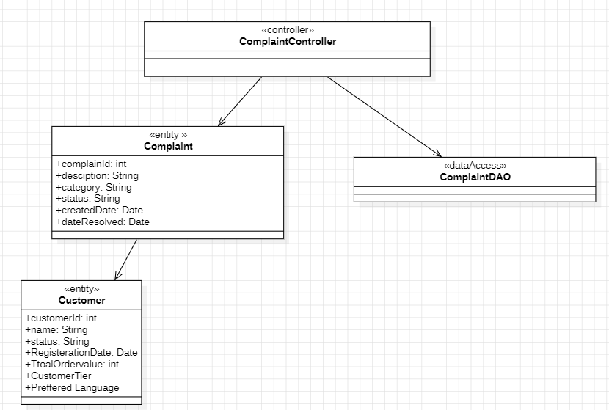

- CRCs for create complaint record:
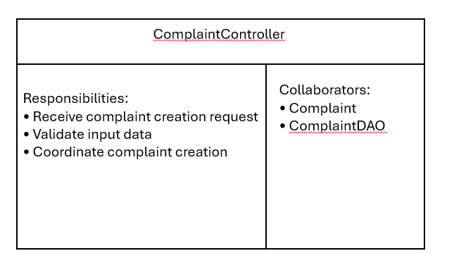
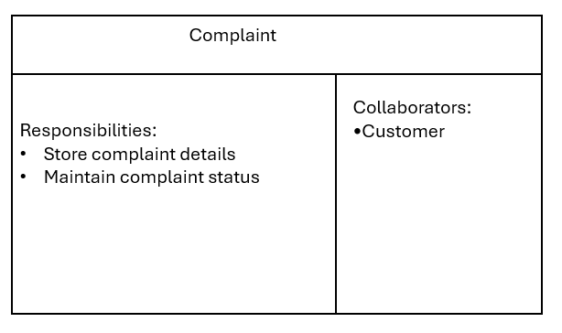
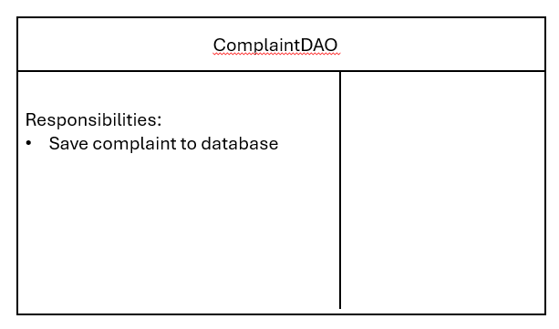

- First-Cut DCD After CRC: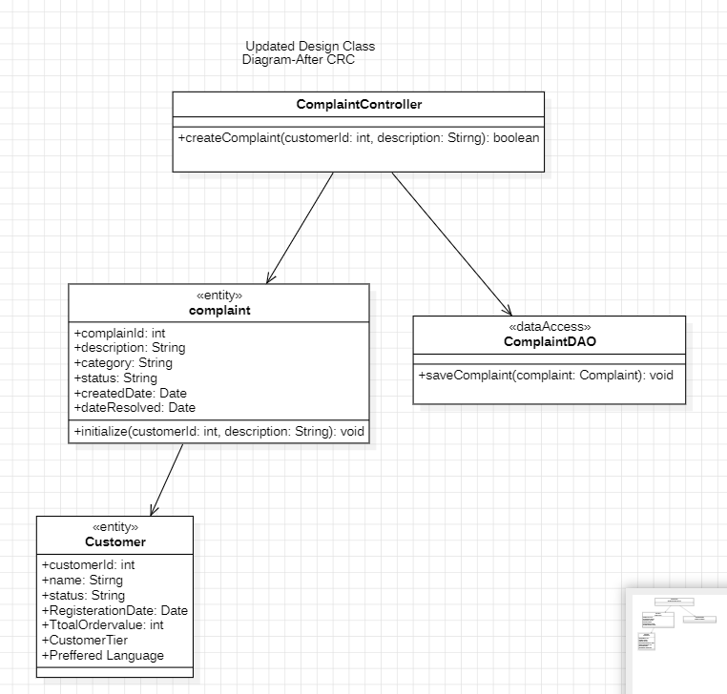

Use Case 2: Resolve Customer Complaint(Moderate)

- First-Cut DCD before communication Diagram:
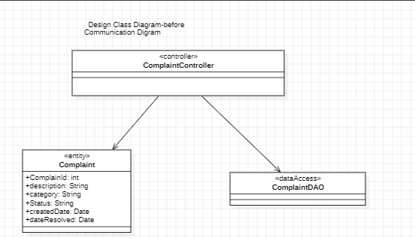

- Communication Diagram:

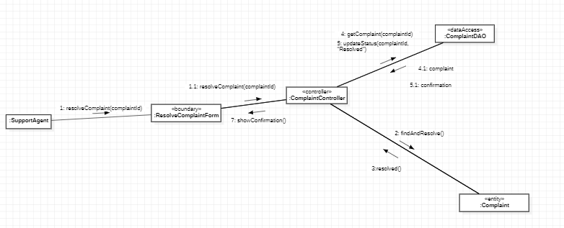

- DCD after communication Diagram:
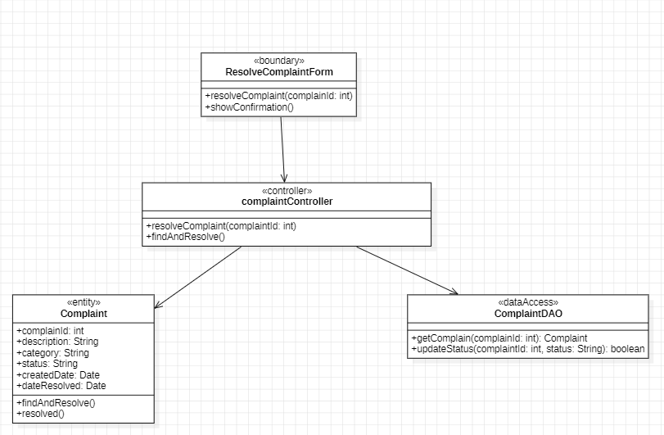

Use Case 3:Escalate Unresolved Complaint (complex):
- First-Cut DCD before Sequence Diagram:
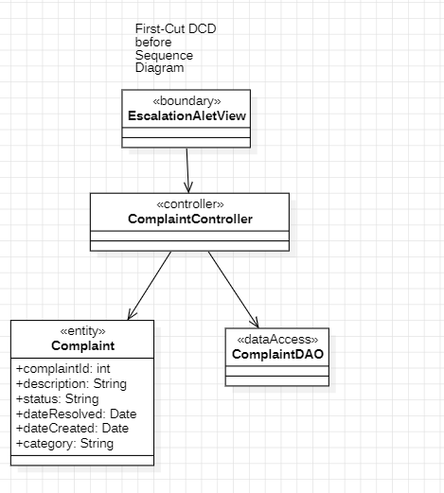
- Sequence Digram:
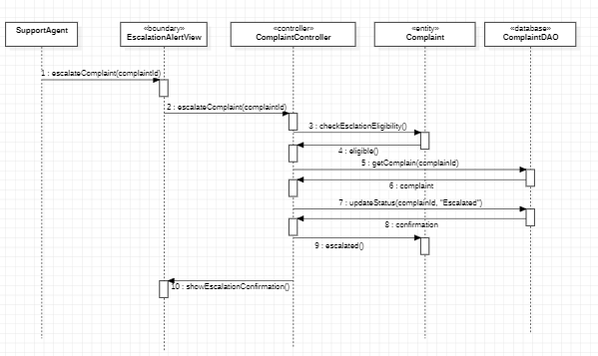

- DCD after Sequence Diagram:
